* The video focuses on providing a deeper understanding of the cost function.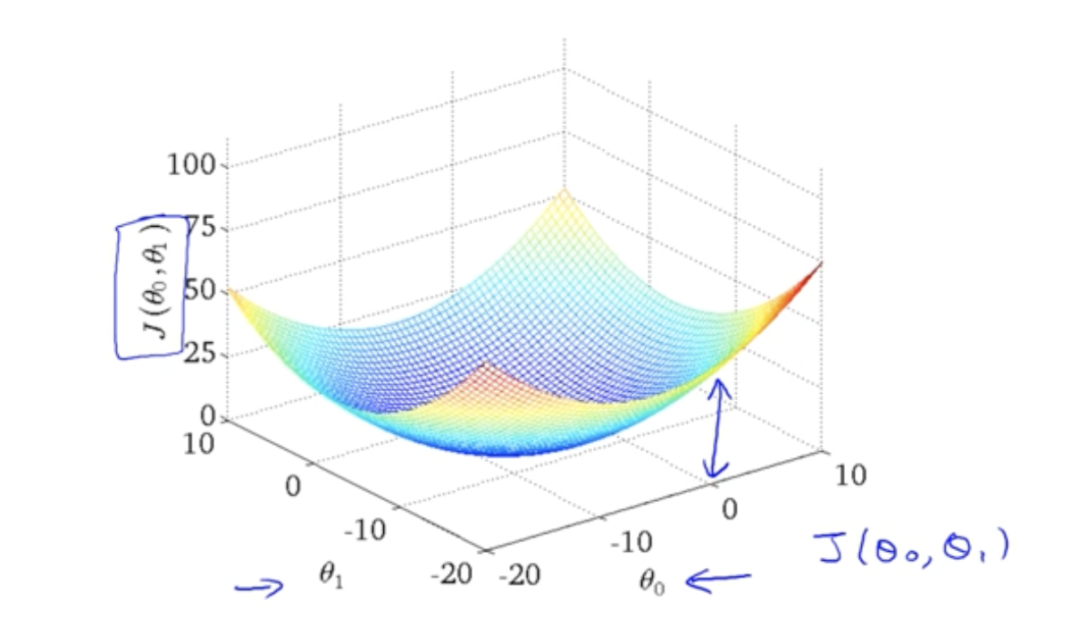
* Contour plots are used to visualize the cost function with two parameters (theta 0 and theta 1).
  + Contour figures can also visualize this, using the rings to represent the costs and the center being the minimum cost.
  + 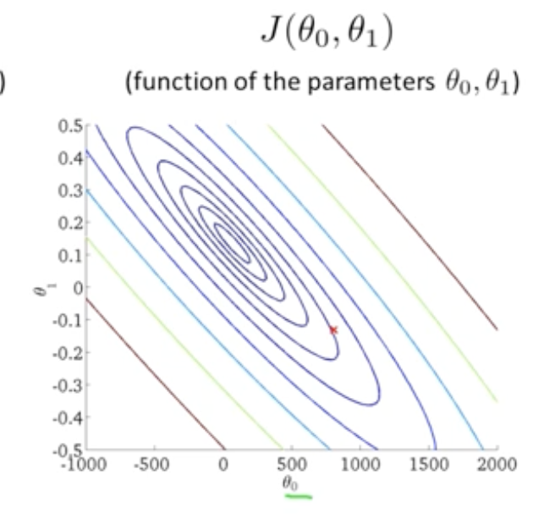
* The cost function appears as a 3D surface with a bow-like shape.
* The minimum value of the cost function represents the best fit to the data.
* Different points on the contour plot correspond to specific values of theta 0 and theta 1 and the corresponding cost.
* Hypothetically, the minimum of the cost function corresponds to the hypothesis that best fits the data.
* Efficient algorithms are necessary for automatically finding the values of theta 0 and theta 1 that minimize the cost function.